Colin Flynn 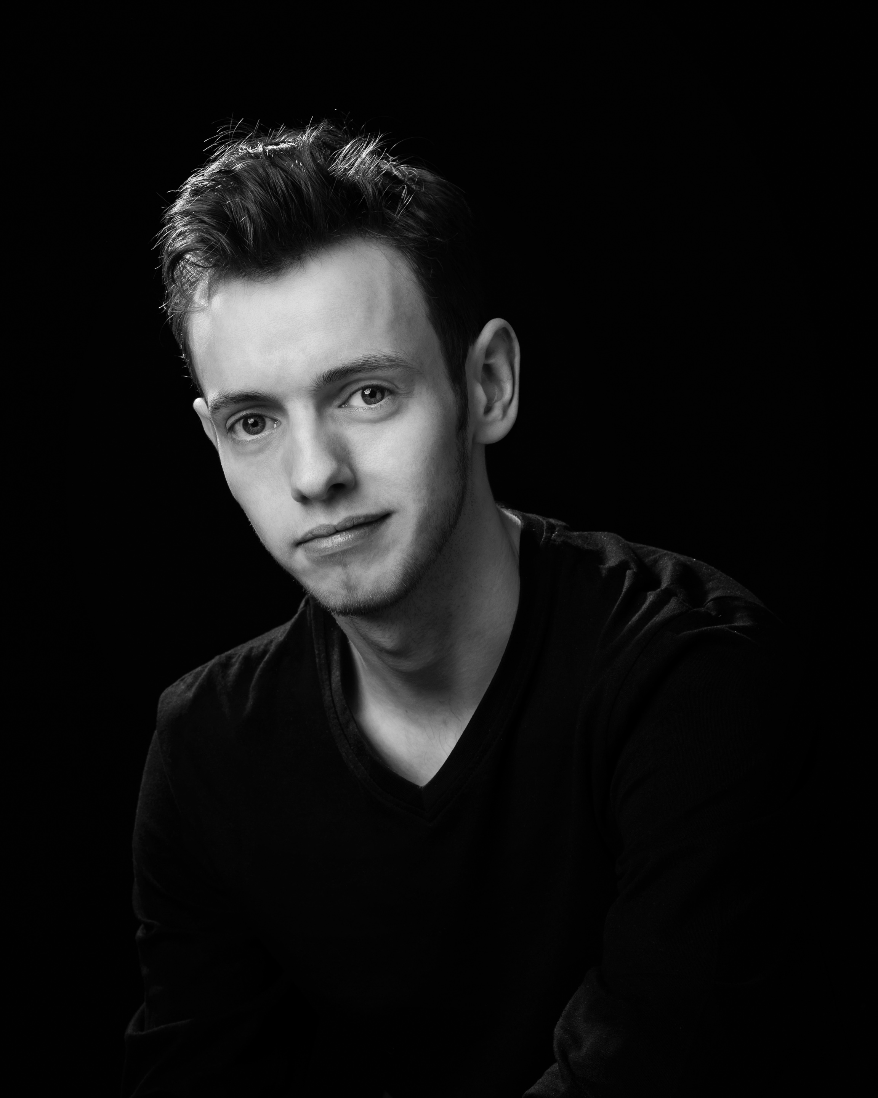

PERSONAL

PLAYING AGE: 19 - 25 HEIGHT 5’ 9’’ (174cm)
HAIR: Brown EYES Blue
NATIONALITY Irish FRAME: Slim

THEATRE

TITLE ROLE THEATRE DIRECTOR
Little Shop of Horrors Seymour Krelbourne Solstice Arts Centre Liam Butler
The Addams Family Musical Gomez Addams Scoil Mhuire Pat McElwain
Avenue Q Rod Solstice Arts Centre Richie Hayes
Les Misérables SE Thénardier The Helix Rachel O’ Byrne
Encore! Featured Soloist Bord Gáis Energy Theatre Pat McElwain
Evita Magaldi Scoil Mhuire Justin Parkes
Les Misérables SE Thénardier Solstice Arts Centre Gareth Mahony
Fiddler on the Roof Motel The Venue Theatre Richie Hayes
Me and My Girl Gerald Bolingbroke Solstice Arts Centre Ray O’ Hare
Juno and the Paycock Johnny Boyle Solstice AC & Scoil Mhuire Brendan Fox
The Plough and the Stars Lieutenant Langon Solstice AC & Scoil Mhuire Kevin Shelly
Disco Inferno Tom Solstice Arts Centre Seán Henderson
Back to the 80s Feargal McFerrin III Solstice Arts Centre Gareth Mahony
High School Musical Jack Scott Solstice Arts Centre Gareth Mahony
HSM2 (European Premiere) Jack Scott St. Mary’s Convent Gareth Mahony
Peter Pan (Pantomime) Peter Pan Summerhill Centre Craig Regan
Snow White (Pantomime) Prince Charming Trim Town Hall Gareth Mahony

Singing Credits
Celtic Arch Male Singer Celbridge Manor GFD Promotions
Irish Ferries Children’s Entertainer Oscar Wilde TheatreWorx(Claire Tighe)
Encore! Featured Soloist Bord Gáis Energy Theatre Pat McElwain

Other Shows
Witches of Eastwick, Jekyll and Hyde, Oliver!, Sweet Charity, Sweeney Todd: The Demon Barber of Fleet Street, South Pacific, Arsenic and Old Lace. Pantomimes – Aladdin, Dick Whittington, Cinderella. Jack and the Beanstalk (Writer/Director)

TELEVISION

CSÍ, RTÉ Factual, 2009.
Vikings, History Channel, Season 4, 2016.

OTHER INFORMATION

Nominated for Best Actor in a Supporting Role (Rod in Avenue Q) by the Association of Irish Musical Societies in 2015.
Directed Transition Year productions of Honk! Jr. and Disney’s Alice in Wonderland for St. Michaels Loreto, Navan (2014 & 2015)
Awarded a full scholarship to attend AIMS Youth Summerschool in 2007.
Featured Soloist in concerts in The Helix, Solstice Arts Centre, Axis Theatre, The Source Theatre, and other venues as well as National Concert Hall alongside Peter Corry.
Attended performance workshops in London School of Musical Theatre alongside West End performers Killian Donnelly, David Thaxton and Nancy O’ Sullivan, as well as one with Peter Corry.
2 years studying acting with Gaiety School of Acting for Youths with Séamus Quinn.
Received a Distinction in RIAM Grade 4 Musical theatre exam.
Voice Training (2007-2012) with Trim Singing Studio (Helen McHugh).
Boyne Community School ‘Drama Student of the Year 2010’ upon Graduation.
Obtained BA Degree in Geography and Anthropology at NUI Maynooth in 2013.

SPECIAL SKILLS

Baritenor Vocalist

Ability to Read Music

Accents and Dialects

Mime/Physical Acting

Comedic Timing

Guitar

Full Clean Driving License

